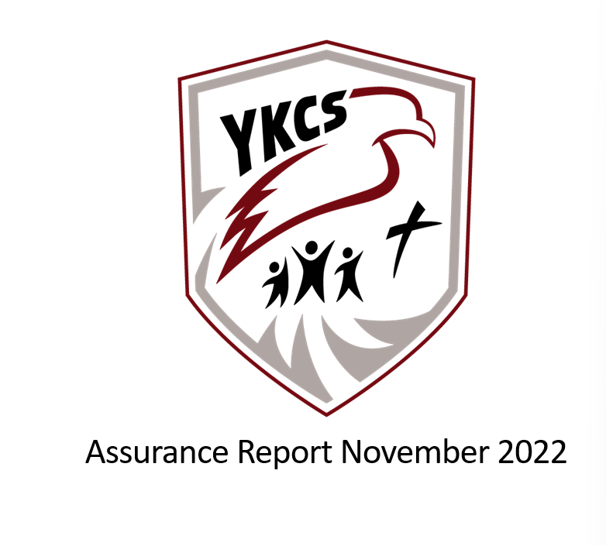

**430 72nd Street, Edson, Alberta, T7E 1N3**

**Email:office@ykcschool.com Website:ykcsschool.com**

**Principal: Lisa Golding Assistant Principal: Colton Black**

**Annual Education Results Report**

**Winter 2024**

Table of Contents

Accountability Statement for the Education Plan 3

Whistleblower Policy: 3

Profile of the School Authority 3

**Mission Statement:** 4

**Vision Statement:** 4

**Statement of Faith:** 4

Domain: Local & Societal Content 6

Rationale: 6

YKCS Measures and Results 6

Community Demographics 6

Family Faith Demographics* 6

7

Domain: Student Growth and Achievement 7

Rationale: 7

Education Plan Outcome 7

High School Completion Results 7

Citizenship 8

Student Learning Engagement 9

Domain: Teaching & Leading 9

Rationale: 9

Domain: Learning Supports 10

Rationale: 10

Education Plan Outcome 10

Welcoming, Caring, Respectful, and Safe Learning Environment 10

Access to Support & Services 11

Domain: Governance 11

Rationale: 11

Parental Involvement 11

Education Plan Outcome 12

YKCS Audited Financial Statements 16

Appendix #1- AERR Original Data 19

19

20

# Accountability Statement for the Education Plan

The Annual Education Results Report for Yellowhead Koinonia Christian School Society for the 2023/2024 school year was prepared under the direction of the Board of Directors in accordance with the responsibilities under the Private Schools Regulation and the Ministerial Grants Regulation. The Board is committed to using the results in this report, to the best of its abilities, to improve outcomes for students and to ensure that all students in the school authority can acquire the knowledge, skills and attitudes they need to be successful and contributing members of society.

This Annual Education Results Report for 2023/2024 was approved by the Board on January 22, 2025.

Respectfully submitted,

Original signed Original signed

Shane Vanderkooi Lisa Golding

YKCS Board Chair Principal

## Whistleblower Policy:

The policy was adopted March 26, 2014. There were no disclosures reported to the chief officer of Yellowhead Koinonia Christian School.

## W

## otection:

### Profile of the School Authority

Yellowhead Koinonia Christian School (Y.K.C.S.) is located at 430-72 Street, Edson, Alberta. We are an accredited, independent, interdenominational school which is parent owned and parent operated with parental involvement in all aspects of school operation. Each year members in good standing with the Society elect parents to our local school board.

The school has existed for over 40 years but in June of 1997 became a part of Koinonia Christian Schools and is currently a premier member of this organization. YKCS is also a member of the Association of Independent Schools and Colleges of Alberta (AISCA) and the Association of Christian Schools International (ACSI).

The building, completed in 2003, includes a gymnasium, chapel, and commercial kitchen. The school building contains 8 classrooms, administration offices, chapel, and a resource room. In 2023-2024 we have 6.0 FTE Teachers, 5.4 FTE special needs assistants, 1 home school coordinator, 1 homeschool facilitator and 1.1 FTE administrators. There are 1.6 FTE programming facilitators. We operate with a 1.0 FTE Receptionist/Bookkeeper.

We offer full and part time ECS programming. The student/teacher ratio being low enables much individual attention, and provides a stimulating, interactive environment where students can experience success. We also work with the Ministry of Children Services to offer a preschool program for kids ages 3 and 4.

Y.K.C.S offers Christian based education and is committed to spiritual and academic excellence in all things for the glory of God.

YKCS offers homeschooling in Edson and surroundings areas with students enrolled from locations in Hinton, Peers, and Yellowhead County. We have also started monthly activities in Whitecourt in hopes to create a homeschooling community in Whitecourt.

Distance Education is a new area that we are offering this year. We are offering print based materials for students in Grades 1-6 and Online learning for students in grades 7-12. We have two cohorts for this current year; a grade 10 group and a grade 7/8 group.

## **Mission Statement:**

Yellowhead Koinonia Christian School is a Christ-centered discipleship school that exists to assist Christian families in developing the spiritual lives and academic potential of its students.

## **Vision Statement:**

YKCS has a vision to glorify our Lord Jesus Christ by preparing students through a quality education characterized by academic excellence and a foundation of truth as revealed in God’s Word. As a distinctly Christian, independent school, YKCS is committed to an example of integrity and service in our community and in developing graduates who understand, embrace and live out a thoroughly Christian worldview.

## **Statement of Faith:**

1. We believe that the Bible, containing the 66 books of the Old and New Testaments, is the only inspired, inerrant, infallible Word of God and is the final authority on the Christian faith and life. (II Timothy 3:16; II Peter 1:21).
2. We believe there is only one God, who exists eternally in three equal persons — Father, Son, and Holy Spirit — and who created out of nothing the heavens and the earth and all that is in them by the power of His spoken word (Genesis 1:1; Genesis 1:26; Psalm 33:6; Matthew 28:19; John 1:1-3; Mark 1:9-11; Hebrews 11:3).
3. We believe that Jesus Christ is both true God and true man (Exodus 3:13-15 and John 8:58-59; John 1:1-18; John 10:30-33; Galatians 4:4-5; Philippians 2:5-8; Hebrews 2:14-18). We believe in His virgin birth (Isaiah 7:14; Matthew 1:18-23; Luke 1:26-35); His sinless life (Hebrews 4:15; Hebrews 7:26); His miracles (John 2:11); His substitutionary death (Romans 4:25; Romans 5:8; Galatians 3:13-14; Hebrews 2:9); His physical resurrection (Luke 24:39-43; I Corinthians 15:1-22); His ascension to the right hand of the Father (Mark 16:19; Luke 24:50-53); and His personal, visible, and bodily return in power and glory to judge the living and the dead (Acts 1:11; Revelation 20:11-15; Revelation 22:12).
4. We believe that men and women were created by God in His own image (Genesis 1:27; Genesis 9:6); that marriage was instituted by God whereby a man and a woman are joined together in lifelong commitment to faithful companionship, and that Biblical marriage is the only legitimate and acceptable context for sexual intimacy (Genesis 2:20-24; Matthew 19:4-6; Romans 7:2; I Thessalonians 4:1-8; Hebrews 13:4). We believe that all men and women are born spiritually separated from God because of sin (Genesis 3:23-24; Romans 3:10-12; I John 1:8-10), and are incapable of being reconciled to God apart from the work of Jesus Christ (Romans 5:6-8; Acts 4:12; Ephesians 2:1-5).
5. We believe in the absolute necessity of rebirth by the Holy Spirit for salvation (John 3:1-3; I Peter 1:23). We believe that man is justified (declared righteous) by God on the single ground of the righteousness of Jesus Christ (namely, His sacrificial and atoning death on the cross to pay the penalty for sin, and His perfect obedience) freely given to all who believe in Him. We believe that this saving work and perfect righteousness of Jesus Christ can only be received by faith alone (Isaiah 53:1-12; Jeremiah 23:6; Matthew 20:28; John 3:16-19; John 5:24; Romans 3:21-26; Romans 4:1-3; Romans 5:8-19; Romans 10:1-10; I Corinthians 1:30; II Corinthians 5:21; Galatians 2:21; Ephesians 2:8-9; Philippians 3:7-9; I John 4:10).
6. We believe in the physical resurrection of both the saved and the lost. Those who are saved will rise to eternal life, and those that are lost to eternal punishment (Matthew 16:27; John 5:28-29; Matthew 25:46; I Corinthians 15:12-17).
7. We believe that the Church is the body of born-again believers in fellowship with Christ and with fellow believers (I Corinthians 12:12-13; Ephesians 2:19-21; Hebrews 10:25).
8. We believe in the presence and power of the Holy Spirit, who indwells believers enabling them to live a Godly life (Romans 8:13-14; I Corinthians 3:16; I Corinthians 6:19-20; Ephesians 2:10; Ephesians 5:15-21). 9)
9. We believe that mankind was created in the image of God, after His likeness and therefore has transcendent, intrinsic worth (Genesis 1:27). The murderous destruction of any human life from conception to natural death is unjustifiable and wrong in the sight of God.
10. We believe that God wonderfully and immutably creates each person as male or female. These two distinct, complementary genders together reflect the image and nature of God (Genesis 1:26-27). Rejection of one’s biological sex is a rejection of the image of God within that person.
11. We believe that men and women were created by God in His own image (Genesis 1:27; Genesis 9:6), that marriage was instituted by God whereby a biological man and a biological woman are joined together in lifelong commitment to faithful companionship, and that Biblical marriage is the only legitimate and acceptable context for sexual intimacy (Genesis 2:20-24; Matthew 19:4-6; Romans 7:2; I Thessalonians 4:1-8; Hebrews 13:4).
12. God has established three institutions within human society—the family, the state, and the church—with the Triune God reigning supreme over all. Each institution, under God, has a sphere of authority with jurisdictional limits that must be respected. The state, at all levels, exists to preserve order in society, to ensure justice for citizens and residents, and to protect families and churches, providing them with the freedom and safety necessary to fulfill their God-given responsibilities (Pro. 8:15-16; Dan. 2:21; John 19:11; Rom. 13:1-7; I Pet. 2:13-16; Tit. 3:1). The church is duty bound to promote the well-being of state and society through its moral and spiritual guidance, its worship and supplication of almighty God (II Chron. 7:14; I Tim. 2:1-6), and its charitable institutions and works (Mat. 5:13-16; Eph. 2:10; I Tim. 6:18; Tit. 2:14, 3:8, Heb. 10:24; I Pet. 2:12).

# Domain: Local & Societal Content

### Rationale:

As an independent Christian school parents only enroll their children – at personal cost to themselves – if they believe that the school provides what their children need and, therefore, need to remain conscientiously accountable to them when setting priorities for the school culture and academics. We also are dependent on churches to communicate our existence to new members of the community, so it is essential that the school is trusted by churches as an institution that is faithful to the values of the Christian community at large. Finally, our students enter the community through service projects, work experience and RAP, so having a strong relationship with community partners affords our students more opportunities in their education and afterward.

### YKCS Measures and Results

### Community Demographics

|  |  |  |  |  |  |  |
| --- | --- | --- | --- | --- | --- | --- |
|  | **2018 – 2019** | **2019 - 2020** | **2020 - 2021** | **2021 - 2022** | **2022-2023** | **2023-2024** |
| **In-School Students K-12** | 70 | 81 | 74 | 71 | 92 | 109 |
| **Homeschool Students** | 17 | 9 | 13 | 16 | 17 | 19 |
| **Preschool Students** | 6 | 10.5 | 6 | 7 | 6 | 20 |
| **Self-Identifying FNMI Students** | 9 | 9 | 9 | 6 | 6 | 9 |
| **Visible Minority Students** | 10 | 9 | 9 | 13 | 5 | 5 |
| **Financial Assistance Students** | 4 | 6 | 4 | 2 | 8 | 10 |
| **Severe Disability** | 5 | 6 | 3 | 4 | 6 | 12 |
| **PUF** | 0 | 1 | 0 | 1 | 1 | 6 |
| **Mild / Moderate / Gifted** | No Data | No Data | 10 | 6 | 7 | 7 |
| **ESL / ELL Students** | No Data | 8 | 7 | 9 | 17 | 23 |

### Family Faith Demographics*

|  |  |  |  |  |
| --- | --- | --- | --- | --- |
|  | **2020 - 2021** | **2021 - 2022** | **2022-2023** | **2023-2024** |
| **Carrot Creek (non-denominational)** | 1 | 2 | 1 | 1 |
| **Alliance** | 4 | 3 | 5 | 7 |
| **Baptist** | 11 | 13 | 12 | 10 |
| **C.R.C.** | 1 | 1 | 2 | 2 |
| **Family of Faith** | 5 | 2 | 1 | 1 |
| **Mennonite** | 3 | 3 | 2 | 4 |
| **Pentecostal** | 6 | 5 | 3 | 8 |
| **Undeclared** | 8 | 1 | 6 | 12 |
| **United** | 1 | 2 | 0 | 0 |
| **Other Nondenominational** | - | 4 | 8 | 8 |
| **Catholic** | - | 1 | 1 | 1 |

*At least one primary care giver from each family is required to sign that their faith is aligned with the school’s statement of faith.

# Domain: Student Growth and Achievement

### Rationale:

Based on standardized test results, our parent surveys and discussion among staff it is clear that there is need for systematic emphasis on Math and ELA.

|  |
| --- |
| Education Plan Outcome |
| **Students achieve prescribed provincial learning outcomes, demonstrating strengths in literacy and numeracy.** |
| Comment |
| Unfortunately, due to our numbers in PAT and Diploma years our student results have been suppressed due to new curriculum, small grade size or alternate year course offering. (See appendix for 2024 graphs) To make sure that students are meeting Literacy and Numeracy targets we have implemented Literacy Assessments using Acadience (K-6) three times a year as well as the Provincial Numeracy Assessments for K-4. This year we have also started using the computer program, IXL, which assists staff and students in tracking success in Language Arts and Math Curriculum. |

**Please see appendix for Assurance Report Data

### High School Completion Results

The data presented by the government is not entirely a fair representation of YKCS in that a number of students, upon graduation, have gone on to post-secondary institutions that are not recognized for this data (eg. Peace River Bible College). As such, when this is considered, our transition rate to post-secondary is close to, if not exceeding Alberta averages. Our data, however, does not account for completion of post-secondary programs.[1]

|  |  |  |  |  |  |  |  |  |  |  |  |  |
| --- | --- | --- | --- | --- | --- | --- | --- | --- | --- | --- | --- | --- |
|  | **2013-2014** | **2014-2015** | **2015-2016** | **2016-2017** | **2017-2018** | **2018-2019** | **2019-2020** | **2020-2021[2]** | **2021-2022** | 2022-2023 | 2023-2024 | Totals & Percentages |
| **Grade 12 In-Class Students** | 5 | 4 | 2 | 4 | 1 | 1 | 5 | N/A | 7 | 3 | 4 | 36 |
| **Completed Diploma** | 5 | 2 | 2 | 4 | 1 | 1 | 4 | N/A | 7 | 3 | 3 | 32/36  89% |
| **Completed Certificate of Completion** | N/A | N/A | N/A | N/A | N/A | N/A | 1 | N/A | N/A | N/A | 1 | 2/36  5.5% |
| **Did not Complete High School** | N/A | 2 | N/A | N/A | N/A | N/A | N/A | N/A | N/A | N/A | N/A | 2/36  6.3% |
| **Went on to Recognized Post-secondary** | 1 | 2 | No Data | 1 | 1 | 1 | 1 | N/A | 3 | 0 | 0 | 10/36  28% |
| **Went on to Unrecognized Post-secondary** | 4 | 0 | 1 | 0 | N/A | N/A | 3 | N/A | 2 | 0 | 0 | 10/36  28% |

Notes:

For the government results please see Appendix 1.

2 In the 2020-2021 school year we did not have any grade 12 students.

### Citizenship

|  |  |  |  |  |  |  |  |  |  |  |  |
| --- | --- | --- | --- | --- | --- | --- | --- | --- | --- | --- | --- |
| Percentage of teachers, parents and students who are satisfied that students model the characteristics of active citizenship. | | | | | | | | | | | |
| Achievement | | | | Improvement | | | Overall | | | | |
| Very High | | | | Declined | | | Excellent | | | | |
| Overall | | 2020 | | 2021 | | 2022 | 2023 | | | 2024 | |
| YKCS | | 97.6% | | 97% | | 87.4% | 92.5% | | | 85.1% | |
| Province | | 83.3% | | 83.2% | | 81.4% | 80.3% | | | 79.4% | |
| Percentage of teachers, parents and students who are satisfied that students model the characteristics of active citizenship. | | | | | | | | | | |
|  | 2020 | | 2021 | | 2022 | | | 2023 | 2024 | |
| Parent | 100% | | 100% | | * | | | 93.8% | 93.2% | |
| Student | 95.1% | | 90.9% | | 74.8% | | | 83.5% | 65% | |
| Teacher | * | | 100% | | 100% | | | 100% | 97% | |

### Student Learning Engagement

|  |  |  |  |  |  |
| --- | --- | --- | --- | --- | --- |
| The percentage of teachers, parents and students who agree that students are engaged in their learning at school. | | | | | |
| Achievement | | Improvement | | Overall | |
| Very High | | Improved | | Excellent | |
| Overall | 2020 | 2021 | 2022 | 2023 | 2024 |
| YKCS | N/A | 92.9% | 83.3% | 91.1% | 92.5% |
| Province | N/A | 85.6% | 85.1% | 84.4% | 83.7% |

|  |  |  |  |  |  |
| --- | --- | --- | --- | --- | --- |
| The percentage of teachers, parents and students who agree that students are engaged in their learning at school. | | | | | |
|  | 2020 | 2021 | 2022 | 2023 | 2024 |
| YKCS Overall | N/A | 92.9% | 83.3% | 91.1% | 92.5% |
| Parent | N/A | 100% | * | 97.4% | 100 |
| Student | N/A | 78.6% | 66.6% | 75.9% | 77.5% |
| Teacher | N/A | 100% | 100% | 100% | 100% |

# Domain: Teaching & Leading

### Rationale:

To support the school’s strategic priorities, it is essential that we provide opportunities for staff to interact with other professionals, sharing strategies, resources, and gain new perspectives on teaching that will grow their capacity to meet the various needs of students.

|  |  |  |  |  |  |
| --- | --- | --- | --- | --- | --- |
| Percentage of teachers, parents and students satisfied with the overall quality of basic education. | | | | | |
| Achievement | | Improvement | | Overall | |
| Very High | | Declined | | Excellent | |
| Overall | 2020 | 2021 | 2022 | 2023 | 2024 |
| YKCS | 98.2% | 96.3% | 92.0% | 94.1% | 91% |
| Province | 90.3% | 89.6% | 89% | 88.1% | 87.6% |

|  |  |  |  |  |  |
| --- | --- | --- | --- | --- | --- |
| Percentage of teachers, parents and students satisfied with the overall quality of basic education. | | | | | |
|  | | | | | |
|  | 2020 | 2021 | 2022 | 2023 | 2024 |
| YKCS Overall | 98.2% | 96.3% | 92.0% | 94.1% | 91% |
| Parent | 100% | 99.2% | * | 93.5% | 97.2% |
| Student | 96.4% | 89.6% | 84% | 91.5% | 78.2% |
| Teacher | * | 100% | 100% | 97.2% | 97.3% |

# Domain: Learning Supports

### Rationale:

According to our Christian identity, YKCS should be a place where staff, students and families work together in the context of their real unity in Christ to make the school a community of learning characterized by peace, joy, patience, kindness, self-control, and generosity. Furthermore, when people do not feel safe, they are not effective workers or learners.

|  |
| --- |
| Education Plan Outcome |
| **Students are active, healthy, and well.** |
| Comment |
| This outcome was chosen as we found the students struggling in multiple areas. Some of this could be attributed to the Trauma of the recent past including COVID-19, a peer suicide, and 3 local emergencies declared in the forms of 2 fires and 1 flood.  To support our students, we developed a mental health proposal and received financial support to hire a counselor and a registered psychologist to assist our students, staff, and families. 2023-2024 saw our highest need of counselling services, with students, with an 59% increase in case load from 2022-2023. The counselor also worked with 2 grade groups of students to support students in learning how to be a good friend and to improve their cooperation.  Our psychologist also added wraparound work with parents meeting with admin, staff, and families together to create a plan that could work at home and school. (10% of our family population).  We continue to offer access to the gym daily as well as on break times when the weather is not cooperating. |

### Welcoming, Caring, Respectful, and Safe Learning Environment

|  |  |  |  |  |  |
| --- | --- | --- | --- | --- | --- |
| The percentage of teachers, parents and students who agree that their learning environments are welcoming, caring, respectful and safe. | | | | | |
| Achievement | | Improvement | | Overall | |
| Very High | | Declined | | Good | |
| Overall | 2020 | 2021 | 2022 | 2023 | 2024 |
| YKCS | N/A | 98% | 90.8% | 93.4% | 86.5 |
| Province | N/A | 87.8% | 86.1% | 84.7% | 93.6 |

|  |  |  |  |  |  |
| --- | --- | --- | --- | --- | --- |
| The percentage of teachers, parents and students who agree that their learning environments are welcoming, caring, respectful and safe. | | | | | |
|  | 2020 | 2021 | 2022 | 2023 | 2024 |
| YKCS Overall | N/A | 98% | 90.8% | 93.4% | 86.5% |
| Parent | N/A | 100% | * | 94.2% | 93.6% |
| Student | N/A | 94% | 81.7% | 85.9% | 66% |
| Teacher | N/A | N/A | 100% | 100% | 100% |

### Access to Support & Services

|  |  |  |  |  |  |
| --- | --- | --- | --- | --- | --- |
| The percentage of teachers, parents and students who agree that students have access to the appropriate supports and services at school. | | | | | |
| Achievement | | Improvement | | Overall | |
| Very High | | Maintained | | Excellent | |
| Overall | 2020 | 2021 | 2022 | 2023 | 2024 |
| YKCS | N/A | 96.3% | 86.2% | 89.2% | 90.4% |
| Province | N/A | 82.6% | 86.1% | 80.6% | 79.9% |

|  |  |  |  |  |  |
| --- | --- | --- | --- | --- | --- |
| The percentage of teachers, parents and students who agree that students have access to the appropriate supports and services at school. | | | | | |
|  | 2020 | 2021 | 2022 | 2023 | 2024 |
| YKCS Overall | N/A | 96.3% | 86.2% | 89.2% | 90.4% |
| Parent | N/A | 100% | * | 90.8% | 98.3% |
| Student | N/A | 89% | 72.4% | 80.1% | 73% |
| Teacher | N/A | 100% | 100% | 96.7% | 100% |

# Domain: Governance

### Rationale:

It is clear biblically that God-gives fundamental responsibility to parents for the education of their children and yet the whole community of faith that surrounds each child bears responsibility as well. As such, inviting parents especially and community members additionally is essential to fulfilling our mission and meeting the needs of our faith community.

### Parental Involvement

|  |  |  |  |  |  |
| --- | --- | --- | --- | --- | --- |
| Percentage of teachers and parents satisfied with parental involvement in decisions about their child's education. | | | | | |
| Achievement | | Improvement | | Overall | |
| Very High | | Declined Significantly | | Acceptable | |
| Overall | 2020 | 2021 | 2022 | 2023 | 2024 |
| YKCS | 100% | 93.8% | 96.7% | 91.9% | 85.3% |
| Province | 90.3% | 89.6% | 89% | 79.1% | 79.5% |

|  |  |  |  |  |  |
| --- | --- | --- | --- | --- | --- |
| Percentage of teachers and parents satisfied with parental involvement in decisions about their child's education. | | | | | |
|  | 2020 | 2021 | 2022 | 2023 | 2024 |
| YKCS Overall | 100% | 93.8% | 96.7% | 91.9% | 85.3% |
| Parent | 100% | 87.6% | * | 93.8% | 83.3% |
| Teacher | * | 100% | 96.7% | 90.0% | 100% |

Professional Learning

|  |
| --- |
| Education Plan Outcome |
| **YKCS staff are dedicated to continued growth as educators so that our students can have the greatest success possible.** |
| Comment |
| Our professional development survey results from teachers continue to score high, though there was a dip last year as two staff were dissatisfied. For the 2024-2025 we are doing a book study on Classroom Management and work through a template with our staff on improvement goal setting and reflection in this area.  Staff are also welcome to also pursue their own professional development interests and financial support as well as class coverage is available.  Teacher growth is support by our contracted Psychologist as she observes the classroom and then meets with the class team and principal to offer suggestions for implementations and answer any questions staff may have. This happens monthly through out the year. |

# FMNI Results

# EAL Results

# Numeracy and Literacy Screenings

|  |  |  |  |  |  |  |  |  |  |  |  |  |
| --- | --- | --- | --- | --- | --- | --- | --- | --- | --- | --- | --- | --- |
| **Numracy Assessment** | | | | | | | | | | | | |
|  | September 2023 | | | | Jan 2024 | | | | June 2024 | | | |
|  | # of Students | NA | RAS | NRAS | # of students | NA | RAS | NRAS | # of students | NA | RAS | NRAS |
| K |  |  |  |  | 13 | 8 | 15 | 77 | 13 |  |  |  |
| 1 |  |  |  |  | 10 | 0 | 20 | 80 | 10 |  |  |  |
| 2 | 4 |  | 25 | 75 |  | | | | 4 |  |  |  |
| 3 | 12 |  | 33 | 67 | 12 |  |  |  |
| 4 | 6 | 100 |  |  | 6 |  |  |  |
|  |  |  |  |  |  |  |  |  |  |  |  |  |
| **Literacy Assessment** | | | | | | | | | | | | |
|  | September 2023 | | | | Jan 2024 | | | | June 2024 | | | |
|  | # of Students | NA | RAS | NRAS | # of students | NA | RAS | NRAS | # of students | NA | RAS | NRAS |
| K | 8 |  |  |  | 9 |  | 5 | 4 | 9 | 0 | 4 | 5 |
| 1 | 9 |  |  |  | 9 | 1 | 5 | 4 | 9 | 0 | 3 | 6 |
| 2 | 6 |  | 4 | 2 |  | | | | 6 | 0 | 0 | 6 |
| 3 | 12 | 1 | 2 | 9 | 12 | 0 | 0 | 12 |
| 4 | 7 | 0 | 0 | 7 | 7 | 0 | 0 | 4 |

Unfortunately, due to some technical errors, we have not yet received our data from Alberta Education on our Numeracy Assessments. Miss Golding has been working with the department to get the data processed.

For Grades 1-6 we benchmark our students three times of year (September, January, and June) while Kindergarten happens in January and June. As we see literacy as an area of growth, we also run an intervention program 4 days a week for these students (25 mins/day). The students are grouped in areas of need based on the data. We also progress monitor biweekly or monthly depending on the needs of the child.

# YKCS Audited Financial Statements

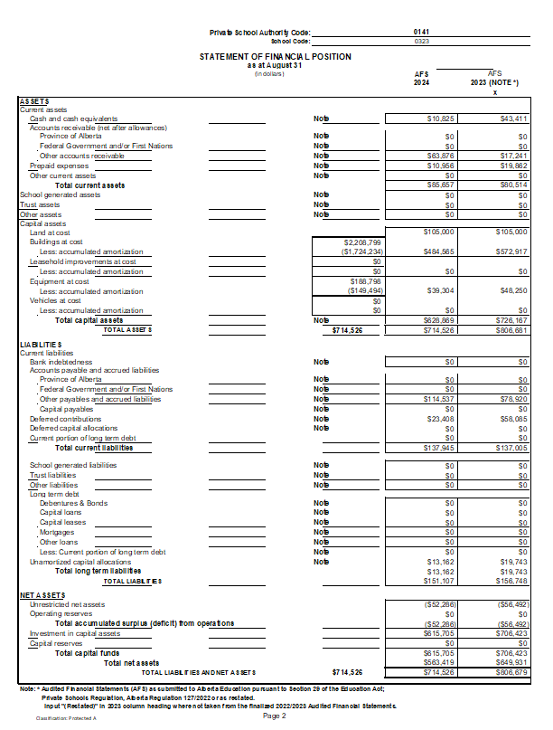

1.
2.